**University of Moratuwa**

**Department of Electronic & Telecommunication Engineering**



**EN2160-Electronic design realization**

**preliminary design report – Coal miner protector**

|  |  |
| --- | --- |
| Index no | 200439G |
| name | P.T.B. Gunatilake |

Contents

**Product description** 3

**People who contributed to conceptually improve the design** 3

**User needs** 3

**Enclosure** 4

Problems/Improvements identified/proposed by members of your group. 4

Problems/Improvements identified/proposed by users. 4

Initial product design vs improved version 4

Solidworks design of the improved product - steps 5

Product with sketches 5

Product design 6

Draft Analysis 6

Die and cavity 7

Final product 8

**Schematic** 9

Problems/Improvements identified/proposed by members of your group. 9

Problems/Improvements identified/proposed by users. 9

improved Block diagram 10

Comparison of old schematic vs improved schematic 11

# **Product description**

Coal mining can be categorized as one of the highest risk occupations in the world, because miners are put into extreme environmental conditions in mines. Hence, it’s important to have proper monitoring system of crucial environment factors inside a coal mine. The “coal miner protector” device is to be developed in a manner where it will keep track of the humidity, temperature, and methane levels inside the coal mine. It will trigger an alarm when any of the above-mentioned environmental factors gets to an extreme condition to human beings.

# **People who contributed to conceptually improve the design**

1. Anuki Pasqual – 200445V

2. Tharusha Pathirana – 200449L

3. Navindu Gunawardena – 200201V

4. Lasitha Jananjaya – 200650U 6.

5. Chehal Jayasuriya – 200262G

6. Chamodh Kavinda – 200301D

7. Malanban Kuganenthiran – 200373X

# **User needs**

Among the targeted market, the functionality of the product has been identified as an essential one, and all of them preferred to get all the environmental parameters to be represented in the mobile app rather than they been displayed on a LCD screen as it would be troublesome to always get near the product to check whether there is a possible danger. Users appreciate its ability to provide timely alerts, ease of use which enables miners to take immediate action when a dangerous situation arises.

When it comes to the enclosure of the product users recommended high tolerance to harsh environmental conditions. They were much more concerned about the strength of the product rather than the user experience because the most of in the interactions of the product can be handled through the mobile app.

So, considering the user needs analysis and the group members feedback mentioned in the conceptual design report we’ve chosen the following enclosure and schematic for the final product.

# **Enclosure**

## Problems/Improvements identified/proposed by members of your group.

* Not proper modifications are applied for upgradability
* Draft angles are not properly set

## Problems/Improvements identified/proposed by users.

* Lack of aesthetics of the product
* Poor user experience

After applying the new knowledge gained from lectures, and considering the feedback received from the users and group members, changes have been made to the enclosure.

* Improved the aesthetics of the product.
* Added the features according to the improved schematic.
* Added drafts angles in order to be able to mold the product in mass production.

## Initial product design vs improved version

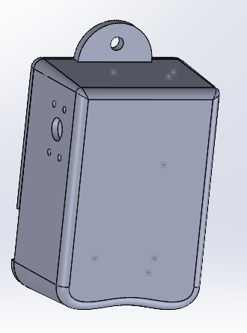

*Previous design improved version*

## Solidworks design of the improved product - steps

### Product with sketches

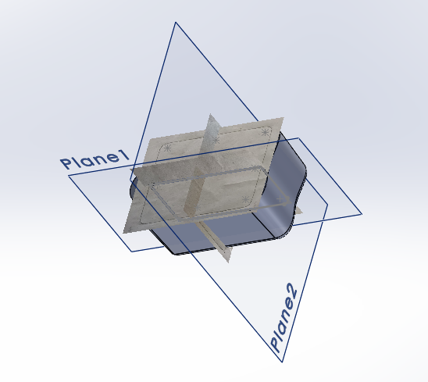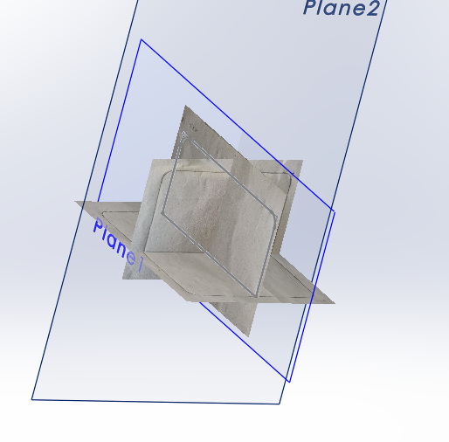

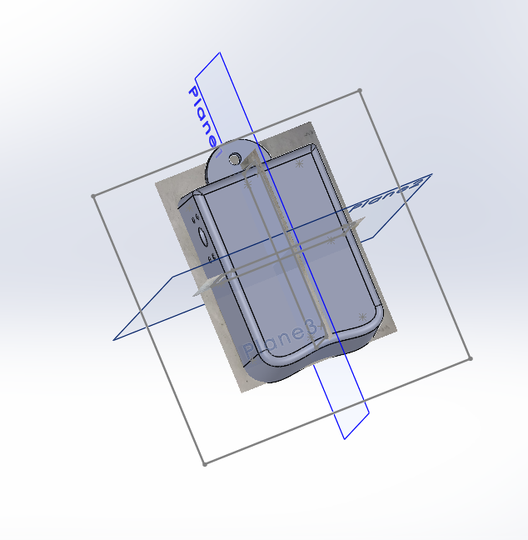

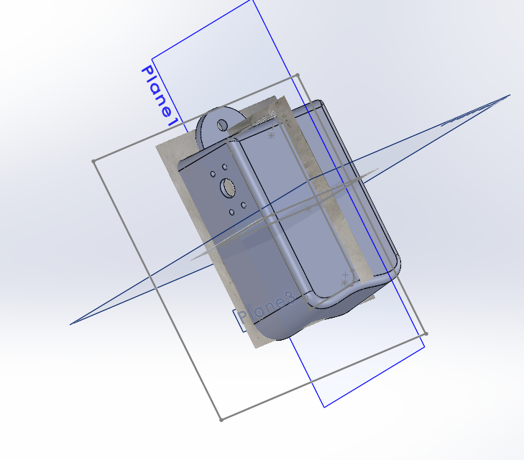

### Product design

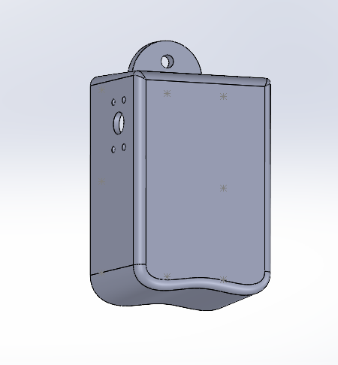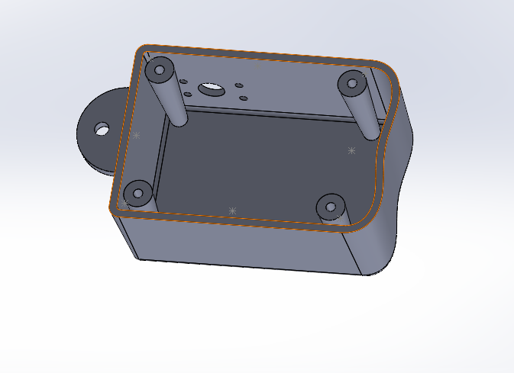

### Draft Analysis

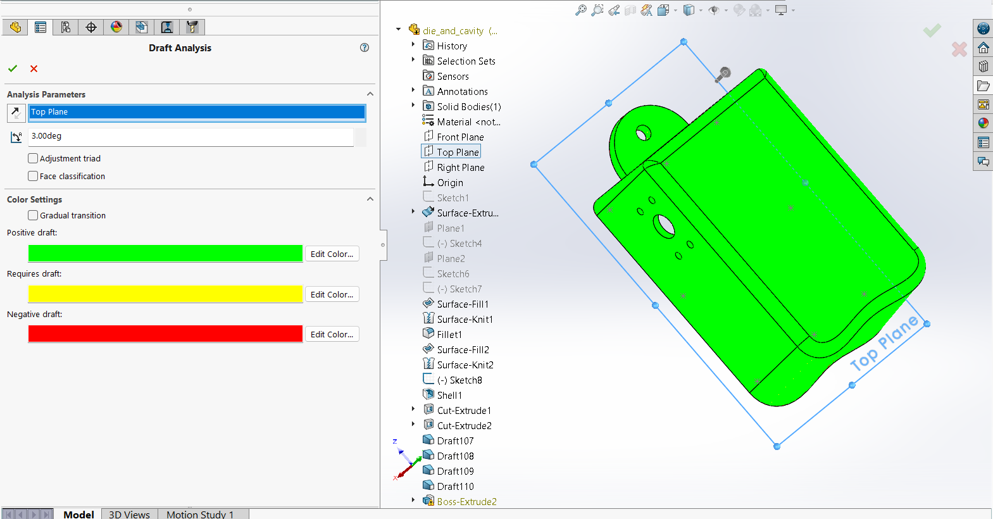

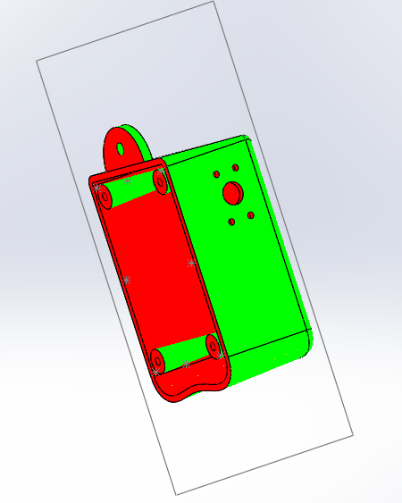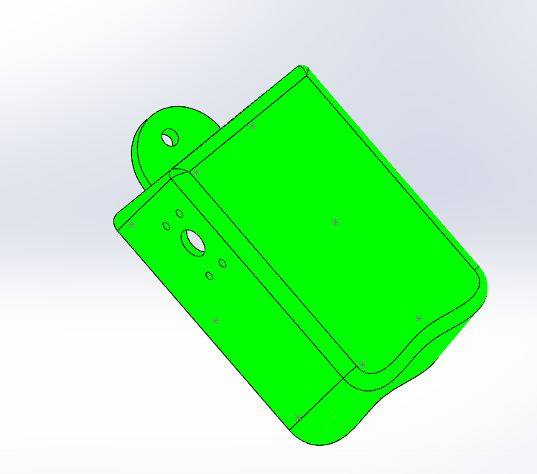

### Die and cavity

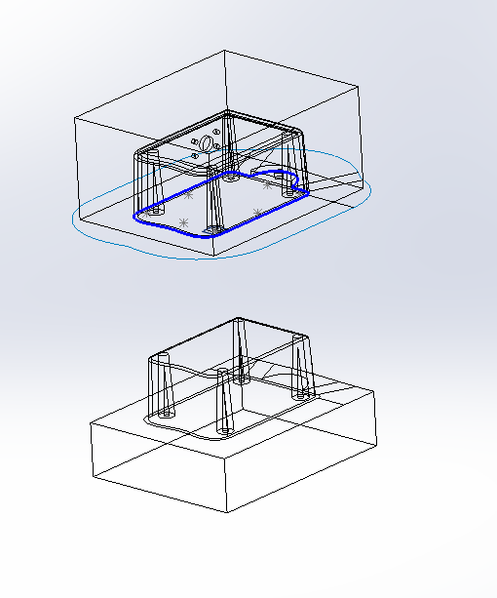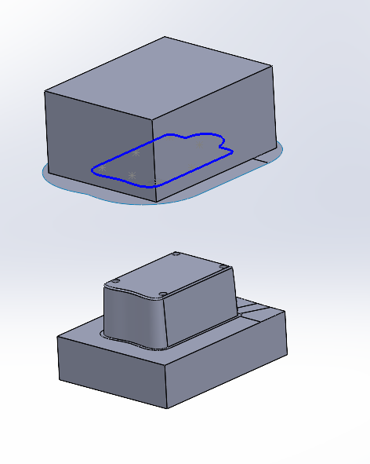

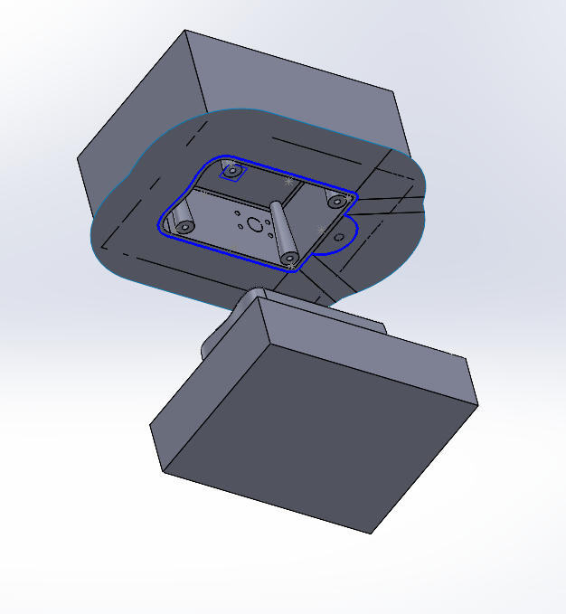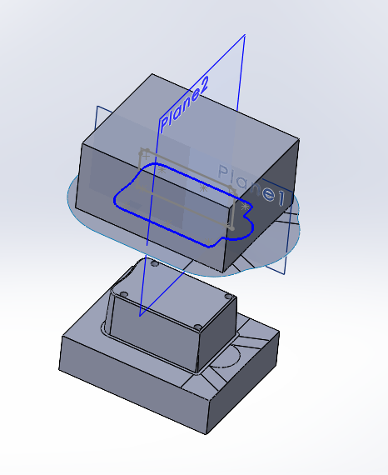

### Final product

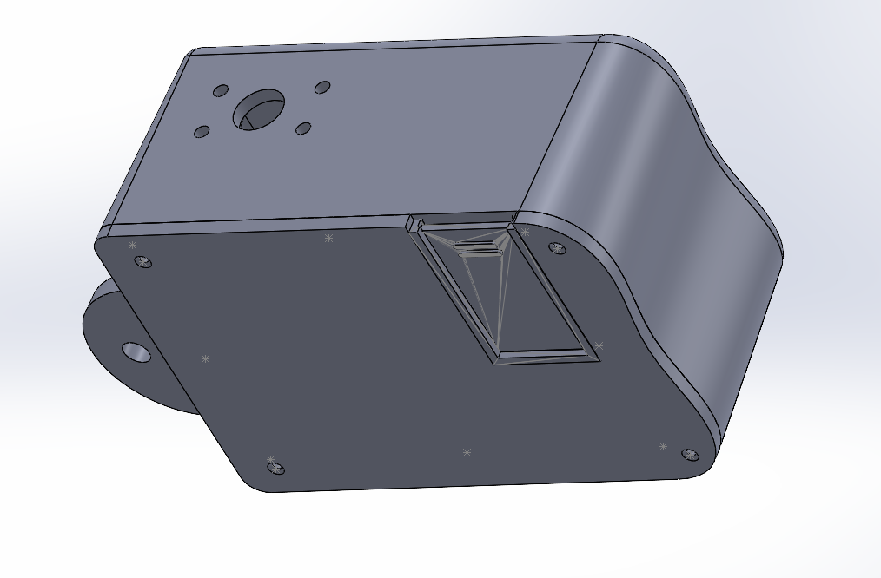

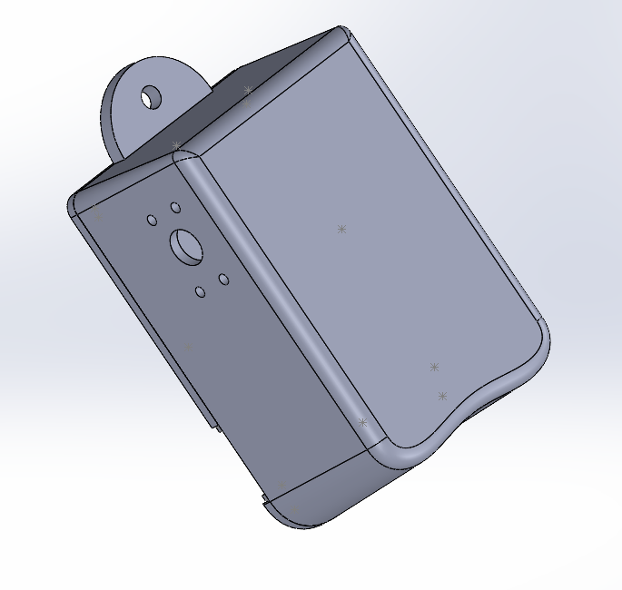

# **Schematic**

## Problems/Improvements identified/proposed by members of your group.

* Less clarity of the condition when it comes to repair/service the device
* Recommend to indicate power on using a some form of indication

## Problems/Improvements identified/proposed by users.

* Recommended the radiation levels measurement apart from the cost as it is critical to safety.
* A way to enter the critical user inputs as a user input

According to users requests of increasing user interactive Ness of the product following changes have been made to the already existing schematic diagram.

* LED indicating the power of the product is on
* LEDs indicating the Sensors and blutooth have been powered up without a failure.
* Apart from the alarm and mobile app notification, a LED indicating any critical situation.
* Added a radiation sensor to keep track of the radiation levels around the environment.

Functional block diagram according to the user/group recommendations and the problems identified considering the course content,

## improved Block diagram

## Comparison of old schematic vs improved schematic

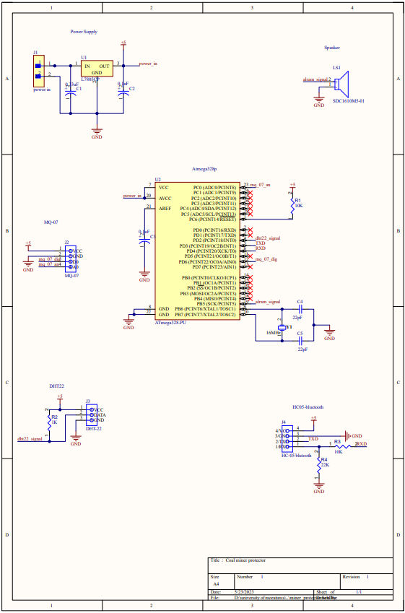

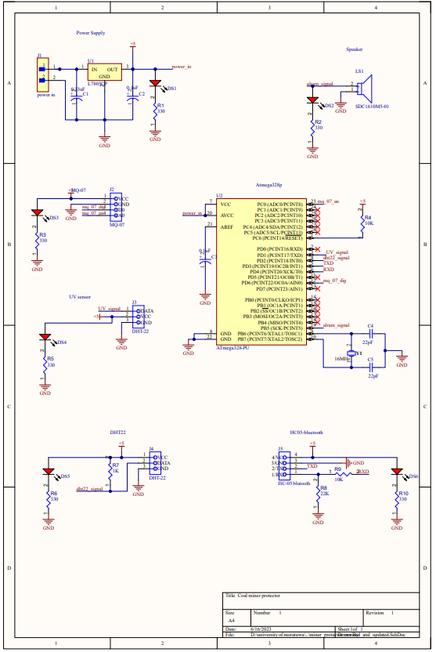

*Old schematic improved schematic*

**I’ve included the improved schematic as the last page of this submission.**